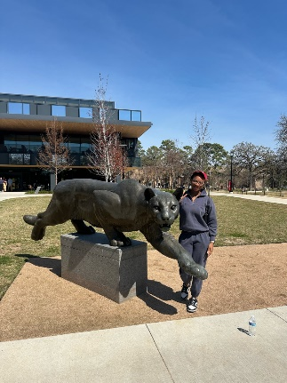
Concept Exercise 1: Caroline Bouillion, Jazlynn Martinez and Noah Norman - COMM 3316

Living Up to More: Zubby’s Journey Through Expectation and Graduation

What kind of pressure comes with being a first-generation college graduate? How does a first-generation student navigate a huge experience like college?
Zubby outside the RAD Center
For many students, graduating college is a personal milestone. For Nzubechukwu Anwaegbu, or
Zubby , it feels bigger than that.
As the youngest of four siblings – a doctor, a teacher and an anesthesiologist – achievement has always been part of the family.
“Once I got to my junior or senior year of college, I started taking initiative to write my own story rather than trying to please anyone else … you should just do what you believe is best for yourself.”
Now a senior preparing to graduate, Zubby is reflecting on what it means to grow up in a high-achieving, strict household while trying to define success for herself.
A Household of Expectations
In Zubby’s family, discipline came early. Structure, routine, and academic focus shaped daily life. Her parents held firm expectations not just for behavior, but for excellence.
With three older siblings who had already built impressive careers, the path ahead of her felt clear.
Zubby says, “My sister is the one person in my life that I think, regardless of what I do, she’ll always be there to support me -- even if I’m doing something wrong. We may be on two different career paths, but I always try to be like my sister in having the same work ethic as her and trying to put my best foot forward.”
“Not only did she grow up with immigrant parents,” said her friend Cameron, “but she had a lot of internal pressure feelings like she had to work her hardest.”
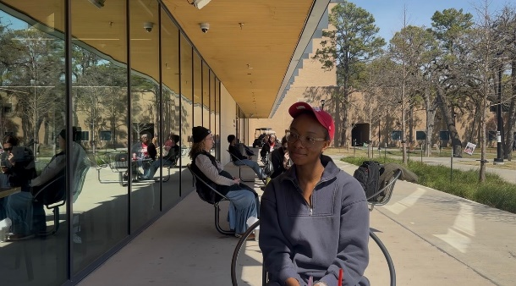
Friends describe her as driven and composed, someone who rarely let's stress show outwardly. Cameron added, “Zubby is very strict with herself. She holds herself to very high standards. Anything she sets her mind to; she’s going to accomplish with no question.”
Away at 14
At 14, Zubby’s life shifted dramatically. Like her siblings before her, she was sent to Nigeria during her teenage years – a decision rooted in discipline, culture and family values.
Zubby during our interview
The move was not framed as a choice. It was the family’s structure.
“The moment I found out Zubby had spent a year in Nigeria, I was shocked,” Cameron said. “It’s not something most people do in high school. Once she told me, though, it made sense – knowing she had Nigerian parents and being able to speak Nigerian. The way she spoke about it felt like she carried so much confidence in her experience.”
Anagha, a longtime friend, remembers that time differently. “I could tell how upset she was about moving over there,” Annika said. “But Zubby has always been highly emotionally intelligent, so she braced herself and went anyway, knowing there was nothing she could do to change her parents’ minds.
Being sent abroad during formative years added another layer of pressure. It meant adapting to a different educational system, cultural expectations and environment – all while maintaining the high standards set at home.
“I didn’t have my siblings with me, and I didn’t know anyone in Nigeria except for my family,” Zubby said.
The experience shaped her resilience. It also deepened her understanding of responsibility – not just to herself, but to her family’s vision of success.
Navigating College
With no prior knowledge of what to expect when attending college, Zubby was tasked with figuring out this daunting landscape on her own.
She mentions living with her grandmothers, who did not have formal education. They helped raise her and her siblings who were still adjusting to a new place. She credits them as huge inspirations for pursuing an education.
Zubby says, “They instilled that faith in me that I am able to do whatever I put my mind to. They are my reason in wanting to go to school and better myself.”
This newfound faith from her support system gave her the confidence to go after a degree in Public Policy, with a minor in National Security Studies.
More Than a Diploma
As graduation approaches, Zubby understands the symbolism of the moment.
She will be joining a family of accomplished professionals. She will add another chapter to a story built on discipline and ambition. But this achievement is uniquely hers.
It represents years of adjustment – from a strict upbringing to international relocation to navigating college largely on her own. It represents her growth into a woman who has learned to balance expectation with identity.
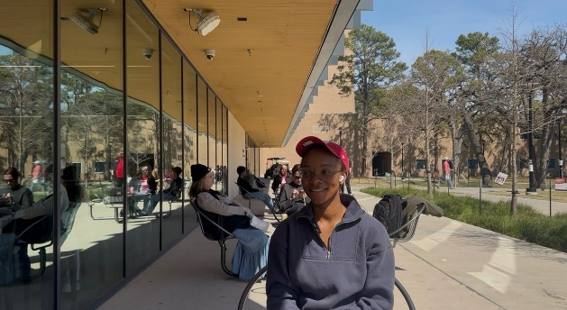
For Zubby, walking across the stage is not just about earning a degree. It will be about proving to herself that she can carry the weight – and still move forward.
Zubby talking about her college experience

